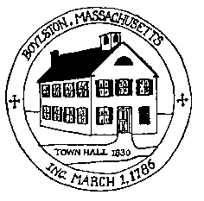
Town of Boylston Planning Board planning@boylston-ma.gov
221 Main Street, Boylston MA 01505 ** Telephone (508) 869-6019 ** Fax (508) 869-6210

AGENDA
Monday, December 5, 2016

7:00 p.m. Review and approve minutes November 7, 2016
and November 16, 2016

7:15 p.m. Compass Pointe-ANR Lot 2

7:30 p.m. Public Hearing Continued Fed Ex

8:30 p.m. ANR-Pine Street-Jimmy Ricciardi/Mike May

