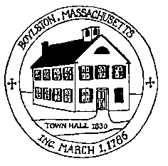
Town of Boylston Planning Board planning@boylston-ma.gov
221 Main Street, Boylston MA 01505 ** Telephone (508) 869-6019 ** Fax (508) 869-6210

AGENDA
Monday, September 12, 2016

7:00 p.m. Review and approve minutes of August 1,
2016
7:10 p.m. Flagg Street- Sokolowski-update

7:20 p.m. ANR-19 Scarhill-Walter Kennedy

7:30 p.m. Ron Aspero/Dick Prince informal discussion
Cottonwood Place

7:45 p.m. Compass Pointe-Lot release

8:00 p.m. Barnard Hill-Bond Reduction, Lot release

8:15 p.m. Mark Donohue/Scannell Properties update

8:30 p.m. Mike May – Camp Harrington ANR

8:45p.m. Mike May-315 Main Street-Phase 1-Prelim Site Plan
Security Monitor Holdings

