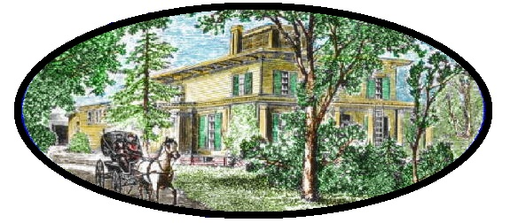

Hillside Restoration Project, Inc.
P.O. Box 454, Boylston, MA 01505

October 1, 2021

Boylston Board of Selectmen
Town Administrative Offices
221 Main Street
Boylston, MA 01505

Dear Board of Selectmen,

The Hillside Restoration Project (HRP) board of directors held its annual meeting, September 22, 2021 to review the past year and discuss the future of our non-profit organization.

One of HRP’s key efforts over the last year was the engagement of Architectural Heritage Foundation (AHF) consultants who completed a Project Positioning Statement for Hillside Farm in June 2021 that provides specific recommendations for the continued restoration of the 12-acre preservation site at Hillside. A copy of AHF’s report is enclosed.

At our meeting HRP board members agreed that AHF’s recommendations provided clear direction, specifically that HRP pause piecemeal or task-specific fundraising and preservation efforts for Hillside Farm until an independent master plan is created for the wider 300-acre Hillside site.

Considering AHF’s recommendations, the HRP requests that the Town take the following actions, as we continue to work in collaboration towards a fully restore and adaptively re-used Hillside Farm.

- Terminate the Gough House lease agreement between the HRP and the Town.

- Maintain full liability insurance for the Gough House and Barn; the HRP would like to discontinue its liability insurance since it has postponed restoration work on the site until a shared vision for Hillside is reached between the Town and HRP.

- Cover heating costs for the Gough House, in the amount of approximately $2,000 annually in order to protect the $1.8 million investment made in capital improvements by the HRP since 2001.

- Cover costs associated with the purchase and installation of a fire alarm system for the Gough House recommended by Bob Bourassa to protect the capital investments made to the house over the last two decades.

Hillside Restoration Project / Page 2

- Increase the Historical Commissions budget to cover general maintenance of the Gough House & Hillside Barn; amount TBD for small capital projects that will protect the significant investment made to date.

- Form an ad hoc committee as part of the current Town Master Plan committee to develop a separate master plan for the Hillside Property, per AHF’s recommendations (a 2010 town study also recommended a master pan for the Hillside site); HRP would be willing to seek grant funding for the Hillside master plan in partnership with the town.

- Publicly support the creation of a citizens group to explore enacting the Community Preservation Act (CPA) for the preservation and conservation of Boylston’s historical and natural resources in partnership with the HRP. A copy of the CPA factsheet is enclosed.

Sincerely,

The Hillside Restoration Project
Board of Directors

Enclosures:
AHF Report
AHF Overview
CPA Factsheet

